|  |  |
| --- | --- |
| EX NO: | **PAYSLIP GENERATION** |
| DATE: |

**AIM:**

To create a java console application to calculate the payment statement for programmer, asst.professor , asso.professor,prof.

**REQUIREMENT:**

To create package payroll, develop a java application with Employee class with emp_name,emp_id,address,mail_id,mobile_no as member.

Inherint the class, programmer, assistant professor associate professor and professor from Employee classs.

Add basic pay(BP) as the member of all the inherited classes with 97% of BP as DA, 10% of BP as HRA, 12% of BP as PF,0.1% of BP for staff club fun.generate payslip for the employee with their GROSS and NET SALARY

**ALGORITHM:**

STEP 1: Declare a package payroll.

STEP 2: Declare the class as employee.

STEP 3: Declare a constructor and add the data member.

STEP 4: Inherit the classes from the super class and add the data member as basic pay.

STEP 5: Calculate the gross salary and net salary based on the in heritages.

STEP 6: Display the results.

**CLASS DIAGRAM:**

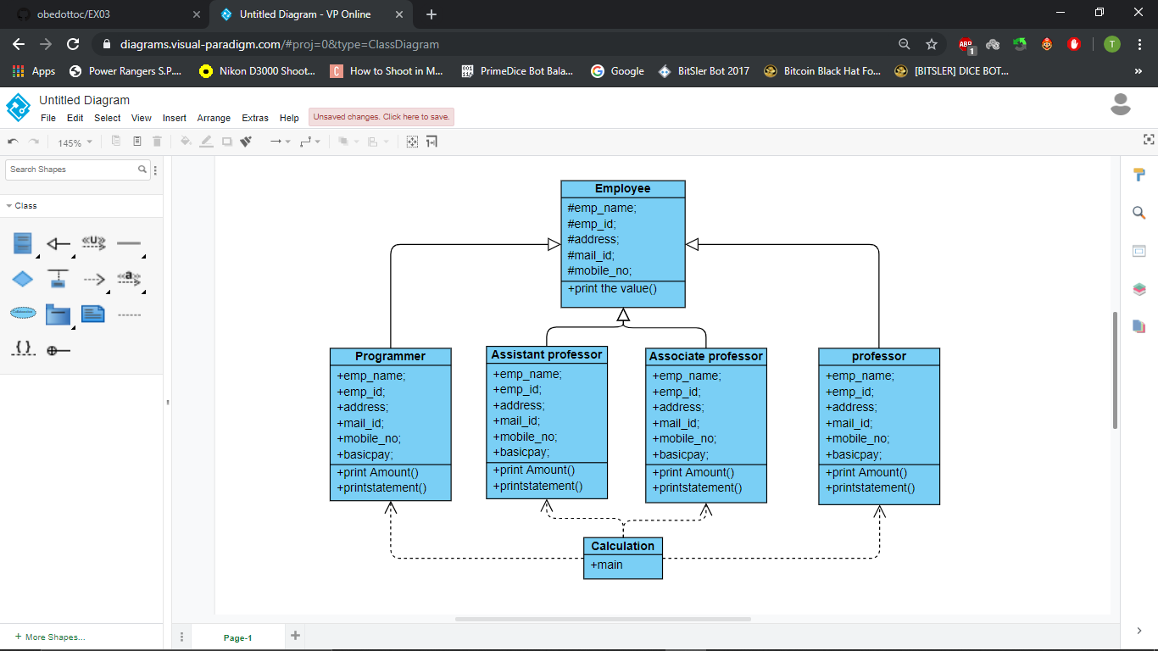

**PROGRAM:**

/**JAVA program to calculate Salary

* author @AKHSHY_GANESH

* reg no: 212217105006

* mail ID: akhshyganeshb@gmail.com

*/

package Payroll;

public class AssistantProfessor extends Employee {

private double BasicPay;

public AssistantProfessor()

{

BasicPay=0;

}

public AssistantProfessor(String n,long id,String adr,String mail,long no,double bp)

{

super (n,id,adr,mail,no);

BasicPay=bp;

}

public void AssistantProfessor()

{

super.printEmployee();

System.out.println("Basic Pay;"+BasicPay);

}

public void calculation()

{double DA,HRA,PF,STAFFCLUBFUND,GROSSSALARY,NETSALARY,DEDUCTION;

DA=0.97*BasicPay;

HRA=0.1*BasicPay;

PF=0.12*BasicPay;

STAFFCLUBFUND=0.1*BasicPay;

DEDUCTION=PF+STAFFCLUBFUND;

GROSSSALARY=BasicPay+DA+HRA;

NETSALARY=GROSSSALARY-DEDUCTION;

System.out.println("BasicPay:"+BasicPay);

System.out.println("GROSSSALARY:"+GROSSSALARY);

System.out.println("NETSALARY:"+NETSALARY);

}

}

package Payroll;

public class AssociateProfessor extends Employee {

private double BasicPay;

public AssociateProfessor()

{

BasicPay=0;

}

public AssociateProfessor(String n,long id,String adr,String mail,long no,double bp)

{

super(n,id,adr,mail,no);

BasicPay=bp;

}

public void printEmployee()

{

super.printEmployee();

System.out.println("BAsicPAy:"+BasicPay);

}

public void calculation()

{double DA,HRA,PF,STAFFCLUBFUND,GROSSSALARY,NETSALARY,DEDUCTION;

DA=0.97*BasicPay;

HRA=0.1*BasicPay;

PF=0.12*BasicPay;

STAFFCLUBFUND=0.1*BasicPay;

DEDUCTION=PF+STAFFCLUBFUND;

GROSSSALARY=BasicPay+DA+HRA;

NETSALARY=GROSSSALARY-DEDUCTION;

System.out.println("BasicPay:"+BasicPay);

System.out.println("GROSSSALARY:"+GROSSSALARY);

System.out.println("NETSALARY:"+NETSALARY);

}

}

package Payroll;

public class Employee {

protected String emp_name;

protected long emp_id;

protected String address;

protected String mail_id;

protected long mobile_no;

public Employee()

{

emp_name="no name";

emp_id=1051;

address="unknown";

mail_id= "unknown";

mobile_no= 9512364;

}

public Employee(String n,long id,String adr,String mail,long no)

{

emp_name=n;

emp_id=id;

address=adr;

mail_id=mail;

mobile_no=no;

}

public void printEmployee()

{

System.out.println("Name:"+emp_name);

System.out.println("Account:"+emp_id);

System.out.println("Addess:"+address);

System.out.println("Email:"+mail_id);

System.out.println("Mobile:"+mobile_no);

}

}

package Payroll;

public class Payslip {

public static void main(String[]args) {

Employee emp;

AssistantProfessor ast;

AssociateProfessor aso;

Professor Prof;

Programmer Prog;

emp=new Employee("Akhshy",212217006,"chennai","ak@gmail.com",95245436);

ast=new AssistantProfessor("faizul",212217016,"chennai","faizul@gmail.com",945744862,32000);

aso=new AssociateProfessor("karan",212217024,"chennai","karan@gmail.com",946894135,36000);

Prof=new Professor("bairavan",212217010,"chennai","mbairavan@gmail.com",923123457,38000);

Prog=new Programmer("sanjai",212217019,"chennai","sanjai@gmail.com",974123431,42000);

System.out.println("----------------------------------------------");

emp.printEmployee();

ast.calculation();

ast.printEmployee();

aso.calculation();

aso.printEmployee();

Prof.printEmployee();

Prog.calculation();

Prog.printEmployee();

}

}

package Payroll;

public class Professor extends Employee{

private double BasicPay;

public Professor()

{

BasicPay=0;

}

public Professor(String n,long id,String adr,String mail,long no,double bp)

{

super(n,id,adr,mail,no);

BasicPay=bp;

}

public void calculation()

{double DA,HRA,PF,STAFFCLUBFUND,GROSSSALARY,NETSALARY,DEDUCTION;

DA=0.97*BasicPay;

HRA=0.1*BasicPay;

PF=0.12*BasicPay;

STAFFCLUBFUND=0.1*BasicPay;

DEDUCTION=PF+STAFFCLUBFUND;

GROSSSALARY=BasicPay+DA+HRA;

NETSALARY=GROSSSALARY-DEDUCTION;

System.out.println("BasicPay:"+BasicPay);

System.out.println("GROSSSALARY:"+GROSSSALARY);

System.out.println("NETSALARY:"+NETSALARY);

}

}

package Payroll;

public class Programmer extends Employee{

private double BasicPay;

public Programmer()

{

BasicPay=0;

}

public Programmer(String n,long id,String adr,String mail,long no,double bp)

{

super(n,id,adr,mail,no);

BasicPay=bp;

}

public void printEmployee()

{

super.printEmployee();

System.out.println("BASIC PAY:"+BasicPay);

}

public void calculation()

{double DA,HRA,PF,STAFFCLUBFUND,GROSSSALARY,NETSALARY,DEDUCTION;

DA=0.97*BasicPay;

HRA=0.1*BasicPay;

PF=0.12*BasicPay;

STAFFCLUBFUND=0.1*BasicPay;

DEDUCTION=PF+STAFFCLUBFUND;

GROSSSALARY=BasicPay+DA+HRA;

NETSALARY=GROSSSALARY-DEDUCTION;

System.out.println("BasicPay:"+BasicPay);

System.out.println("GROSSSALARY:"+GROSSSALARY);

System.out.println("NETSALARY:"+NETSALARY);

}

}

**RESULTS:**

Thus the java console application for Currency converter, Distance converter & Time converter is verifed with output.